WOOD * FIRE * EARTH * METAL * WATER
_______________________________________________________________________________________________________________________________________________
‘The 5 Elements’
STUDY GUIDE

Page 2 DEAR TEACHERS – Introduction
Page 3 BACKGROUND NOTES and 5 Elements Chart
Page 4 WHAT IS AN ELEMENT? Info and Word Game
Page 5 THE 5 ELEMENTS - Listen & Draw Exercise
Page 6 CONNECT THE ELEMENTS – Class Discussion,
Map Work, Time Zones & International Date Line
Page 7 FAMILY, COOL SCHOOL & HAPPY SONG
Listening Exercises
Page 8 HAI JAI MAI (BIG EARS) - Hyperbole
Page 9 MIXING BOWL BAND – Make Your Own Band
SCOTT WONG SONG – Imagination Exercise
Page 10 CHINESE CHARACTERS – History and Web Links
Page 11 RICK SCOTT and HARRY WONG – Brief Bios
Page 12 COLOUR ME! Download Study Guides
Mail Order CDs and Videos
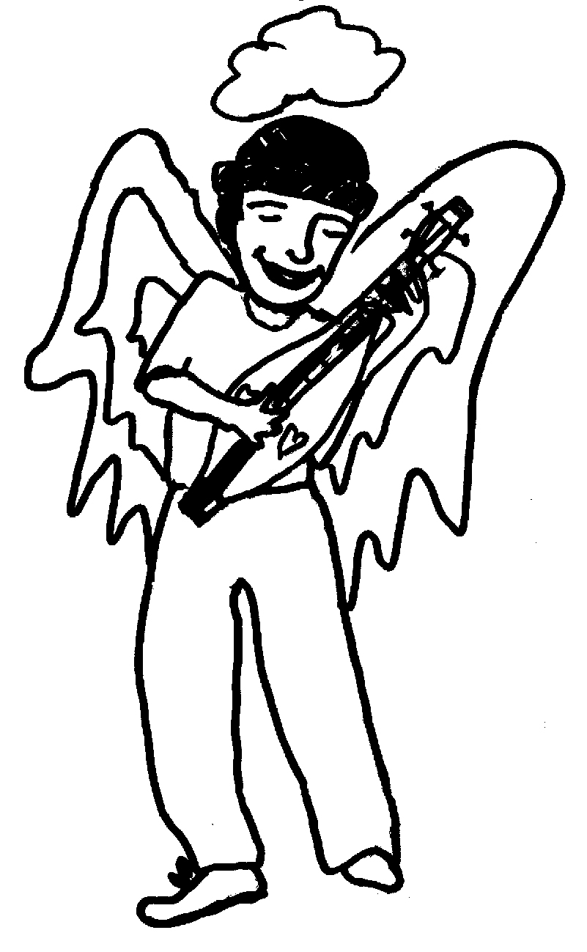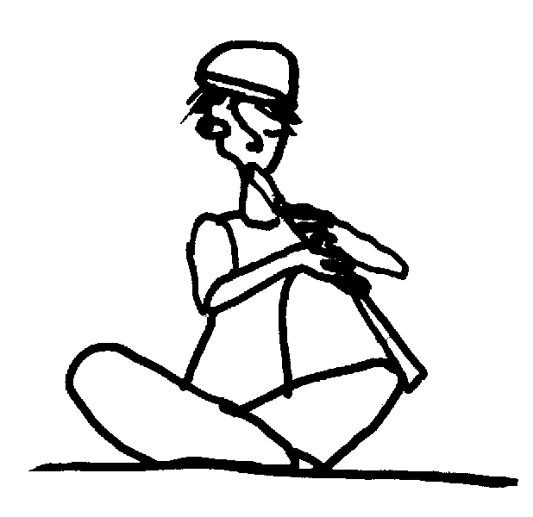
www.rickscott.ca www.harrywong.cc
DEAR TEACHERS…

My name is Rick Scott and I live on a small island off the coast of B.C. Harry Wong lives on a small island off the coast of China. We met at an international children’s festival in Hong Kong in 2002. As performers we are kindred spirits. As humans we are 10,000 kilometers and 16 hours apart!

Like his father before him, Harry is a celebrated magician and classically trained recorder master. He wrote the recorder textbook that’s used in Hong Kong schools! He asked me to teach him to play the dulcimer and that’s how our friendship was born. That simple request blossomed into the musical collaboration called THE 5 ELEMENTS. It is a bridge between our worlds.

Despite the vast difference in our cultures and backgrounds, Harry and I discovered we have a lot in common. We both have a quirky sense of humour! Harry’s lyrics are imaginative, insightful and clever. His amazing Cantonese interpretations of my songs create a wonderful window into Oriental family life, school, customs and friends. His fluency in English allows him to leap back and forth between languages in a highly creative way that we hope will intrigue and engage. The CD insert contains not only all the lyrics as sung, but also, where useful, English translation of the Cantonese interpretation.

We encourage you to play the CD in the classroom and give you permission to copy this study guide and the CD for your own use at school. Each song relates to one or more of the elements - WOOD, FIRE, EARTH, METAL, WATER – which all exist in infinite relationship to each other. This study guide contains background information, word games, exercises and colouring pages—something for all ages and levels of development.

Please teach the names of the 5 elements before coming to see the show.

THE 5 ELEMENTS is a work in progress. As Harry and I take the show across Canada, we know we are going to learn a lot more. We’d love to hear what happens in your classroom--your feedback is greatly appreciated.

Teachers, please email me at rick@rickscott.ca. Have your class send me a letter by snail mail to 548 Rosehill St., Nanaimo, B.C. V9S 1E6. I will write back though it may take a while so please be patient! See you soon…

Dulcimerrily yours, Rick Scott
THE 5 ELEMENTS – BACKGROUND NOTES

In the West for hundreds of years people thought the world was made up of 4 elements - EARTH, AIR, FIRE and WATER. In the East, traditional Chinese wisdom believed the world to be made up of 5 basic elements – EARTH, WOOD, FIRE, METAL and WATER. These 5 elements correspond to all aspects of life, including the seasons, climates, colours, shapes, growth stages and organs in the body. The relationships between the elements determine whether or not life is in balance. The art of balancing the 5 elements to be in harmony in your life and surroundings is called Feng Shui.

We balance the elements every day in real life. If we are cold we chop wood to create a fire. If the fire gets too big we put it out with water. As fire burns it leaves ashes that make up soil or earth. When earth is heated, metal ore is extracted. As metal is heated it eventually liquefies. Water is sucked up by the transpiration of plant life to make wood. Fire melts metal; a metal tool chops wood; wood plunges its roots down into the earth, breaking it up; earth creates a channel through which water flows to create a river. The relationship between the 5 elements may be seen as a circle or cycle.

Each element relates to the form or shape of the natural world. Wood relates to the rectangle; Fire to the triangle; Earth to the square; Metal to the dome; Water to asymmetrical curved shapes like raindrops. Here’s a chart that defines some of these associations:

ELEMENT | COLOUR | BODY PART | SHAPE | EXAMPLE
WATER | Black | Ear | Oval | Puddle Ocean
FIRE | Red | Tongue | Triangle | Candle,  Sun
METAL | White | Nose | Semi circle | Scissors Car
WOOD | Green | Eye | Rectangle | Tree  Table
EARTH | Yellow | Mouth | Square | Clay pot Garden

WHAT IS AN ELEMENT?

The word ELEMENT means the simplest part of anything, the part that comes first, the part that can’t be separated into simpler parts. You may already know the word ELEMENT if it appears in the name of your school: ELEMENTARY. Elementary school means the first school you attend, before high school or university. It’s where you learn the basic ideas that you will need to build your understanding.

ELEMENT also refers to fundamental principles and substances. A substance is the material from which something is made. In chemistry an ELEMENT is a substance that can’t be separated by ordinary chemical means into any substance different than itself. There are more than 100 chemical ELEMENTS including gold, silver, oxygen, hydrogen, iron and sulphur.
EXAMPLE: A chocolate chip cookie is not an ELEMENT because it’s made up of flour, butter, sugar and chocolate. And these substances are not elements because they can be broken down into other substances. Gold is an ELEMENT because it CAN’T be broken down into anything but gold. You can melt it, cut it up, freeze it, but it’s still all gold.

Find the 5 elements in your own back yard. A seed is planted in soil (EARTH); WATER and sun (FIRE) help it to grow into a tree (WOOD); we take METAL from EARTH for a saw to cut it down so we can build a table; we burn the branches for FIRE to keep us warm and use the ash to enrich the EARTH.

WORD GAME – Exercise for Desk or Blackboard
QUESTION: What are the basic elements that make up words?
ANSWER: Letters.
QUESTION: How many words can you find using the letters in the word ‘ELEMENTARY’? So many things are made up of the same basic elements!
ANSWER: We found over 50 words! Here they are in alphabetical order--let us know if you find more!

E L E M E N T A R Y
A, am, are, art, ate, eel, elate, element, enamel, enter, entry, lame,
lane, late, lean, lee, leer, leery, let, man, Mary, mar, mart, mat, mate,
me, meal, mean, meant, meat, meet, men, mental, name, nary, ram,
rat, rate, ray, real, rent, rental, tam, tame, tar, tea, teal, tee,
tram, tray, tree, ream, reel, rental, yam, yet.
THE 5 ELEMENTS

This is the story
of Mother Earth

The world is round and round
it never tires of spinning
spinning out
a thousand million things
under the circle
of the sun

WOOD gives birth to FIRE
FIRE becomes EARTH
inside EARTH there is GOLD
GOLD gathers WATER
to nourish all the plants
this is the poem
and the law of the land

Our journey is long
and I am far from home
with a thousand million questions
spinning in my dreams
who can I turn to?

TRACKS 1 & 13: THE 5 ELEMENTS - Listen & Draw
These songs introduce the 5 elements-- WOOD, FIRE, EARTH, GOLD and WATER—and describe the relationship between them. Listen to Track 1 then name the 5 elements. In your own words, describe the relationship between any 2 of them. What does it mean: WOOD gives birth to FIRE; FIRE becomes EARTH; inside EARTH there is GOLD? Now listen to Track 13 - 5 ELEMENTS DANCE. Rick translates Harry’s poem into his own words. Find the words that describe the shape of the circular relationship between the 5 elements? (Round, around, spinning, circle = cycle)

Create your own written language made of pictures. Draw a character to represent each of the 5 elements. Compare it to the character in the chart on page 3. Draw a picture of this song. Make up a story in your own words about the relationship between each of the elements. Make a mask for each element and put on a play showing their interaction.
CONNECT THE ELEMENTS – Imagination and Class Discussion
Each song on the CD relates to one or more of the 5 elements. The elements are connected to each other in many different ways. Play a song and ask the class to name one element it could correspond to and to explain why. The possible answers are endless, there’s no right or wrong answer, but here’s some suggestions: FAMILY = Wood (Family tree); I GOT MONEY = Metal (Gold); MIXING BOWL BAND = Metal (pots and pan).

MAP WORK - On a map or globe, locate Canada and China. Find Vancouver Island and Hong Kong. Both are islands. What is an island? What ocean lies between Canada and China? How long would it take to cross that ocean by boat? by airplane? When Rick is going to bed in Canada today, for Harry it is already tomorrow in Hong Kong. What is the time difference between B.C. and Hong Kong? (16 hours). What is a time zone and why do we have them?

TIME ZONES – As the sun travels around the earth, day and night occur at different times on different parts of the globe. To account for this, the world is divided into a number of time zones. There are approximately 24 time zones spaced at intervals of 15° in longitude. Within each time zone, the hour and minute of the day is the same. Time zones are usually specified by the number of hours they differ from Greenwich mean time. Greenwich, England is defined as the 0 of longitude. Time zones are further complicated by Daylight Saving Time, a one hour shift seasonally inserted in some (but not all) time zones. What time zone do you live in? Name other time zones in Canada? Do you have Daylight Saving Time where you live?
WEB LINK: http://scienceworld.wolfram.com/astronomy/TimeZone.html
INTERNATIONAL DATE LINE On a globe, find the International Date Line (180th meridien), the imaginary line that separates two consecutive calendar days. The date in the Eastern hemisphere, left of the line, is always one day ahead of the date in the Western hemisphere. Without the International Date Line travelers going westward would discover that when they returned home, one day more than they thought had passed. This first happened to Magellan's crew after the first circumnavigation of the globe. Likewise, a person traveling eastward would find that one fewer days had elapsed than he thought, as happened to Phileas Fogg in "Around the World in Eighty Days" by Jules Verne.
WEB LINK: http://aa.usno.navy.mil/faq/docs/international_date.html

TRACK 2: FAMILY – Listening Exercise
As you listen to the song FAMILY, imagine that Rick and Harry are standing on mountains in Canada and China, calling across the Pacific Ocean, telling each other about their families. See if you can hear names of family members and colours in both English and Cantonese. How are they similar? How are they different? Children in Hong Kong call Harry Wong “Harry Goh Goh” which means “Big Brother Harry.” Here are phonetic translations:
Sister - Jay Jay Brother – Goh Goh Mother - Ma Ma Father - Ba Ba Uncle - Bah Bah Aunt – Sam Sam
TRACK 3: COOL SCHOOL – Listening & Drawing Exercise Listen! There are 3 people singing this song: who is that funny voice? That voice belongs to Harry’s cheeky puppet, GIGIJUM, a 65 year old elementary school student with blue hair—you can see his picture in the CD insert. In COOL SCHOOL Harry is telling us about 3 different kinds of schools in Hong Kong and GigiJum keeps interrupting him! GigiJum is very famous because kids see him every week on Harry’s TV show, BEANSLAND, seen in Canada every Sunday on Fairchild TV. Draw a picture of GigiJum. Draw a picture what your own puppet would look like if you had one.

TRACK 5: HAPPY SONG – Listening Exercise
In China everyone know this melody. It’s a very famous Chinese folk melody called HAPPY that Harry made up these cheeky words for. What are two themes of HAPPY SONG? (Singing and Eating). Food is very important in Chinese culture, and some things we find very strange are considered delicious there (eg bird nests and monkey brains). Name some of the foods mentioned in the song. Have you ever eaten any of them? Listen for the pipa coming in part way through this song. A pipa is a traditional four stringed Chinese instrument that looks a lot like Rick’s dulcimer. Eating and singing are mixed together in this lyric: at first Rick and Harry like the song and hate the food, but by the end of the song how do they feel? What happens to the TEMPO of the song at the end? What does it make you want to do? Can you conduct this song and change tempo when it does?

Harry wrote the words to this song are written in the style of Gilbert and Sullivan who wrote popular operas. Find a traditional version of HAPPY and a song by Gilbert and Sullivan and discuss how Rick and Harry combined these two styles of writing.
TRACK 4: HAI JAI MAI (BIG EARS) – Hyperbole (Exaggeration)

ENGLISH LYRICS TRANSLATION OF CHINESE LYRICS
CHORUS: My friend, my friend Dry Shrimp Boy – Hai Jai Mai
Has the biggest ears in the world My best friend is lovely and kind
Til north is south and east is west I’ve been to Hen Chin, the South Pole
My friend and his ears are the best And Africa and never met anyone
With ears ten feet tall

They are so huge, we were playing One day we were playing on the street
We got hit by a terrible storm Suddenly there was wind and rain
He wrapped his ears around us His big ears were covering me
With room to spare So useful, those ears
We were laughing Thanks to him, Dry Shrimp Boy
And dry and warm Hai Jai Mai

They are so awesome His ears catch wind
They flap in the wind Particularly in summer
Oh no, he might blow away! Looking like a flying parrot
But wait! He makes them like wings Taking me up into the sky
We fly away on our own holiday Fly and fly in the sky- HOLIDAY!

1. Children all around the world have a best friend. Harry translated Rick’s song into Cantonese and his best friend’s name is HAI JAI MAI, which means “little dry shrimp boy.”

2. Listen to the song once and concentrate on the English. Then listen to it again and focus on the Chinese. Can you imagine what Harry is saying? Read out loud the English translation of the Chinese lyrics then listen to the song again. What is the same about the two stories? What is different?

3. This song is a good example of HYPERBOLE. Look this word up in the dictionary to see what it means. ANSWER: Exaggeration.

4. Give some examples of imaginative exaggeration from the song. Draw a picture of one of these. ANSWER: Biggest ears in the world /afraid that he might blow away / wrapped them around us with room to spare/ he makes them like wings and we all fly away on our own holiday.” Make up some exaggerations of your own. For example, I’m so hungry I could east a horse. OR My sandwich is so big that it can feed everyone in the whole class, etc.

TRACK 10: MIXING BOWL BAND – Make Your Own Band! This song uses many different kitchen utensils as musical instruments. Listen to see how many you can name. Make your own band using pots and pans and other ‘found’ instruments.
At the beginning of the song, before the first verse begins, Harry is singing in Cantonese the 4 ways to cook things: Pan Fry, Stir Fry, Simmer, Deep Fry. He then translates the chorus as Rick sings it in English. In the CD insert there is an English translation of the Cantonese Verse 3. Read it out loud and discuss how Harry expands on Rick’s idea of having your own kitchen band. As a class or individually, write your own verse for this song.
TRACK 11: SCOTT WONG SONG – Imagination Exercise This silly song is an audio cartoon. Listen to the song and make up a story about what you think is happening.
Here’s the story we made up: What if mice got into the studio late at night and recorded their own song? SCOTT WONG SONG was improvised by several of the musicians who played on the CD. They were given 10 minutes each to be a ‘mouse’ and make up a part for this song. Close your eyes and ‘see’ the mice in your mind while the song is playing. The mice tip over a barrel full of instruments then begin to play and sing. What instruments can you hear? There’s piano, saxophone, trombone, clarinet and pipa. Improvise an audio cartoon in your classroom using found instruments like rulers, pencils and empty jars. Colour the picture below!
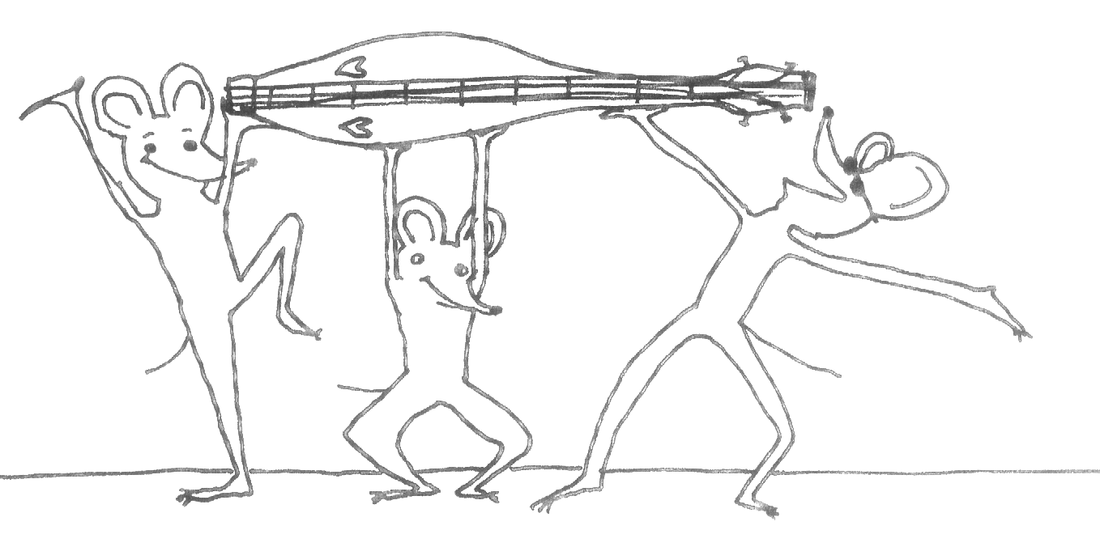
CHINESE CHARACTERS
The Chinese language is over 3500 years old. It does not have an alphabet but uses characters that are a picture or pictograph. Every character represents only one syllable, which is why it can sound harsh to Western ears. Each character has two parts, one representing meaning and one representing sound. The traditional character for WATER originated in cave drawings and looks like 3 streams of water. The character for FAMILY looks like a roof with piglets living under it. Written Chinese can be read as many different spoken languages, including Cantonese and Mandarin Some common English words that come from Chinese are silk, typhoon and kung fu.

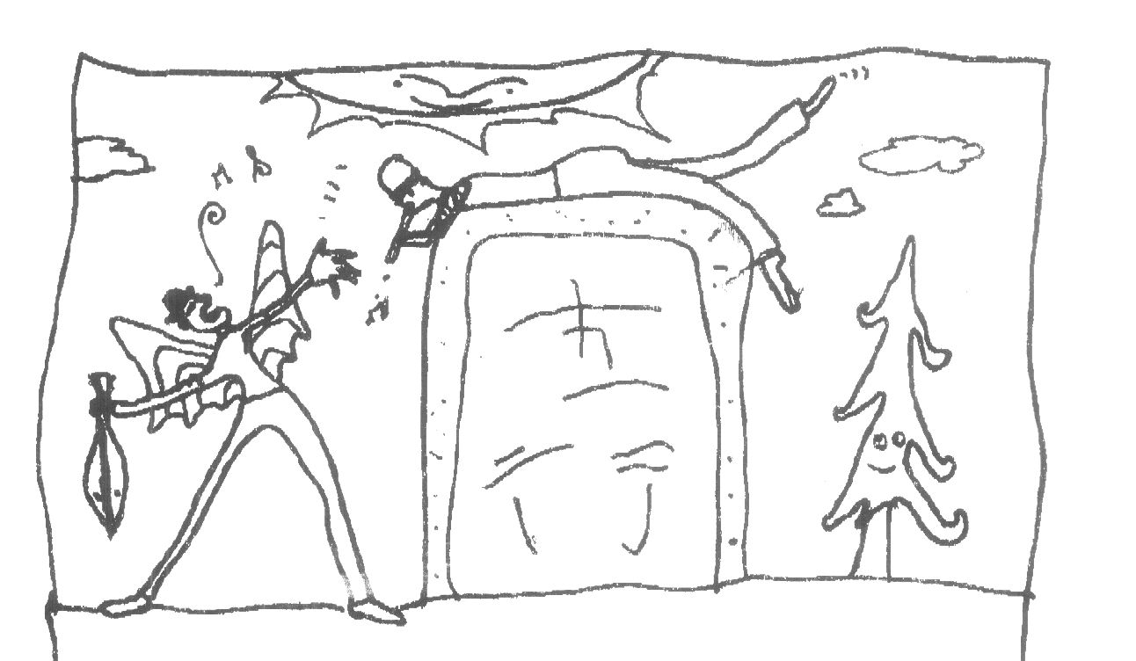
WEB LINKS FOR CHINESE CHARACTERS
http://zhongwen.com - Does Chinese have an alphabet?
Are characters pictographs? How old are Chinese characters?
http://www.ocrat.com/chargif - Animated Chinese characters
RICK SCOTT and HARRY WONG
BRIEF BIOGRAPHIES
RICK SCOTT is a veteran Canadian singer, songwriter and family entertainer. His many kudos include a Juno nomination, a West Coast Music Award, a Children’s Music Web Special Judges’ Award and two Parents' Choice Awards. He is a master of the Appalachian dulcimer which he plays in his own unique style. He has performed his humorous original music for all ages solo in nine countries, including over 1000 schools in which his songs are used to augment curriculum. He is Goodwill Ambassador for the Down Syndrome Research Foundation and gives inspirational keynotes around the world. When not performing for children, Rick tours with Joe Mock and Shari Ulrich in BC’s legendary folk trio Pied Pumkin. Rick is writing a children’s novel entitled THE GREAT GAZOON. In 2005 he will premier a new interactive show at Vancouver’s H.R. MacMillan Space Center called DULCIMERS IN SPACE.

HARRY WONG is a highly esteemed Hong Kong musician, magician and educator. Known in Asia as “Harry Goh Goh” or “Big Brother Harry”, he is famous for combining his unique style of magic and music in TV programs and performances. He is author of the MUSIC TODAY textbook series and a manual for teaching recorder which are used extensively in Asian schools. Harry studied recorder at the Royal School of Music in England and is fluently vernacular in English and Cantonese. He is artistic director of The Hong Kong Children’s Art Academy and a member of many international magicians’ associations. Harry’s weekly Hong Kong TV series, BEANSLAND, is currently shown in Canada on Sundays on Fairchild TV.
Colour Me!
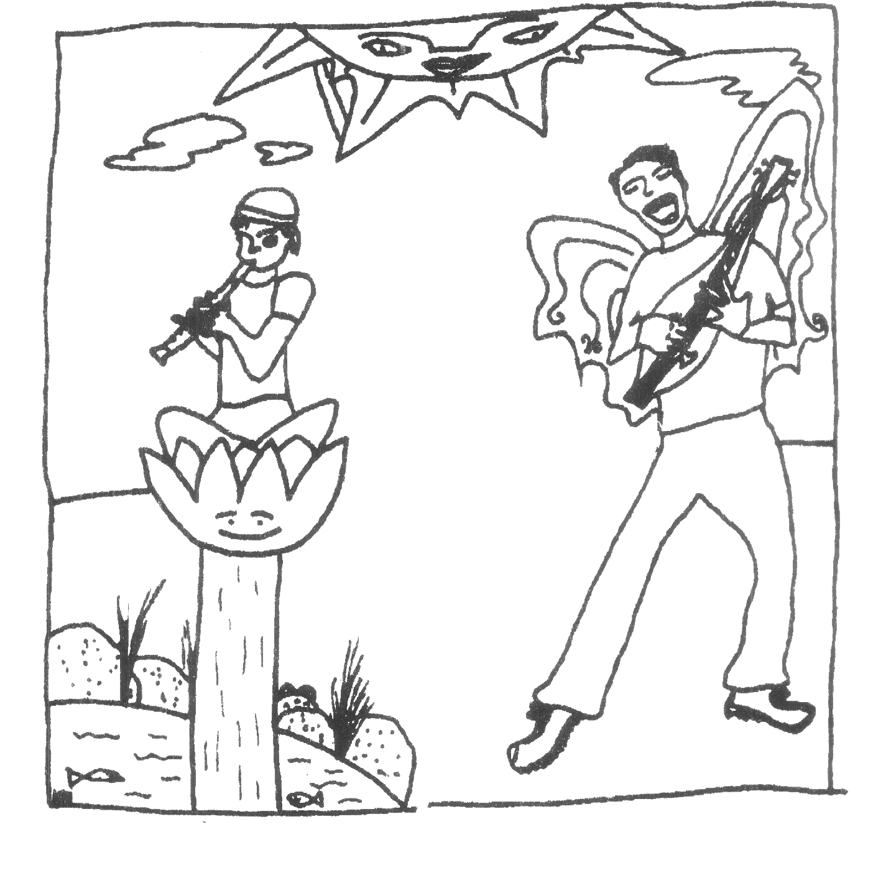
This study guide was written by Valley Hennell in collaboration with Rick Scott and Harry Wong. The cartoons were drawn by Kari Burk. We would appreciate your suggestions and feedback, please email them to vhennell@island.net.
You can DOWNLOAD Rick’s study guides and purchase his recordings and videos from his website www.rickscott.ca. Other recordings include: THE ELECTRIC SNOWSHOE, RICK AROUND THE ROCK, PHILHARMONIC FOOL and MAKING FACES. VHS videos are YO MO CONCERTO and ANGELS DO. Email rick@rickscott.ca.

