For distribution before the ROOTS & GROOVES school performance
* D E A R T E A C H E R S *
Hi, I’m Rick Scott and I’m a singer, songwriter, musician, actor and grandfather.
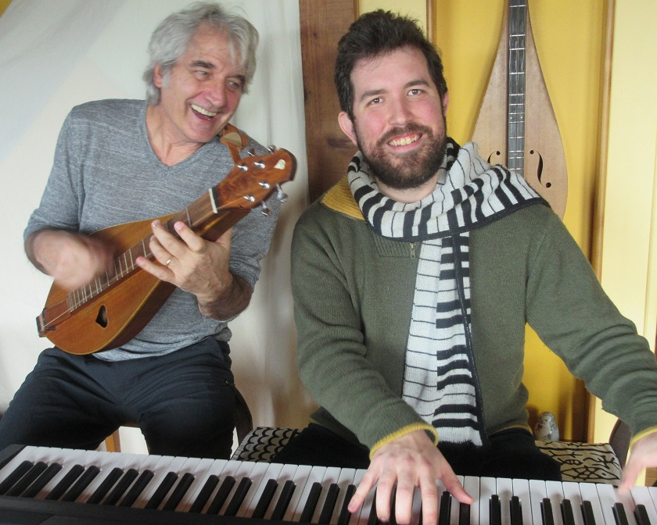I play a folk instrument called Appalachian mountain dulcimer and I’ve performed in 1000 schools in 9 countries.
Nico Rhodes is a classically trained pianist, arranger and musical director, with his own jazz trio and 30 stage musicals to his credit. When he was 8, I played a concert in Nico’s school and he wrote me a fan letter. When he was 23, he orchestrated my songs for symphony. Together we are the inter-generational duo Roots & Grooves.
I choose to work with children and schools to take music out of the mysterious realm of rock concerts and YouTube and bring it live to your gymnasium where we can all make music together. I believe that everyone has natural musical ability and there's no right or wrong way to express this. Each of us has our own voice and our own song and our show encourages students to explore these abilities together: the “you can do it too” method of making music.

Nico and I welcome participation. Perhaps seeing a young man and an elder having so much fun making music together will encourage your students to try an instrument or to persevere in practicing one or begin a dialogue about attitudes toward aging. There will be a question period at the end of the show and we are not offended when asked our ages! I’m 70 and Nico is 29.

We will leave two CDs and a study guide for your school library or music teacher. Elementary grade study guides are available at www.rickscott.ca/resources (click Teachers). We hope these will help you to extend our performance into the classroom. Feel free to duplicate music and printed materials for your own use.

We thank you for the opportunity to make music with you and your students and we’d be delighted to have your feedback. If your class writes to us at the address below, we’ll write back (sometimes it takes a while). Note that we do not respond to student email!

I’m Goodwill Ambassador for the Down Syndrome Research Foundation and have two videos celebrating children with special needs: ANGELS DO and UPSIDE OF DOWN. www.rickscott.ca/videos

MAIL STUDENT LETTERS TO: 58 Pirates Lane, Nanaimo, B.C. V9R 6R1
Teachers’ email contact: info@rickscott.ca
Website www.rickscott.ca
